Pokhara University

Level: Bachelor | Semester – Spring | Year : 2005
Programme: BE |  | Full Marks: 100
Course: Engineering Mathematics IV |  | Time : 3hrs.

Candidates are required to give their answers in their own words as far as practicable.
The figures in the margin indicate full marks.

Attempt all the questions.

 | - Define analyticity of a complex valued function f(z). Show that u = x³-3xy² is harmonic and find harmonic conjugate of u.  - State and prove Cauchy integral formula. Evaluate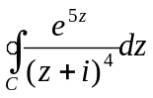, where C is the circle |z| = 3, counter clockwise.  OR  Find Laurent series of the function f(z)=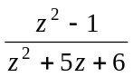in the region  2 < |z| < 3 | 8  7
 | - State Cauchy Residue Theorem. Evaluate  i) 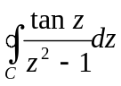, where c is the circle. |z| = 3/2 in counter clockwise direction.  ii) 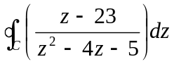, where C is the circle |z-2| = 4, counter clockwise.  - Define z- transform. State and prove linearity property of z-transform. Evaluate Z(te^{2t}). | 8  7
 | - Show that Z[nf(t)] = -z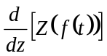. Using it evaluate Z (nt) and Z(n²t).  - Solve the difference equation by using z- transform y_{n+2} – y_{n} =2^{n}, where y₀ = 0, y₁ = 1. | 8  7
 | - Find the solution of one dimensional heat equation of a rod of length L. With boundary condition u(o,t) = 0 = u(L,t) for all t and initial condition u(x,0) = f(x).  - Solve one dimensional wave equation with initial deflection 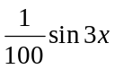and initial velocity is zero with length L = and c² = 1. | 8  7
 | - Write down Laplacian in polar co-ordinate and cylindrical co-ordinates.  OR  Define potential function and then find the solution of potential function. by spherical membrane.  - Maximize z = 5x₁ + 10x₂ subject to 0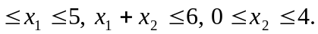 | 8  7
 | - Show that 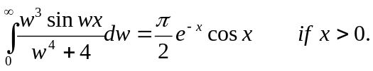  OR  Let f(x) be continuous and absolutely integrable on x-axis, let f '(x) be piecewise continuous on each finite interval and let f(x)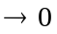as x, then 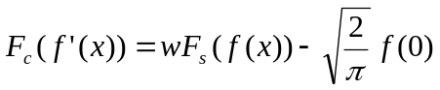and  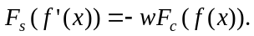  - Find Fourier transform of f(x) = 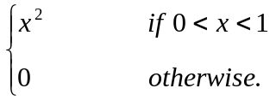 | 8  7
 | Attempt all:  - Evaluate 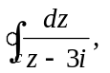where c is the circle, |z| = 4 counter clockwise direction.  - Find Maclaurin expansion of the function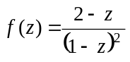.  - Solve by using separation of variables u_{x} –u_{y} = 0.  - Find Z^{-1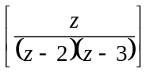.}  - Find the position vector of the curve x²+y² = 1, y = z in parametrical representation. | 2  2  2  2  2

